**Three Rivers Museum**

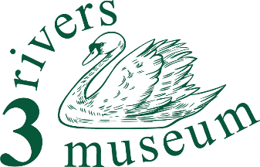

**Admin team member**

**Summary**

You’ll support the secretary and chairman in the running of our small organisation.

**Detailed description**

What will I do?

Many and varied things, to be agreed with the Secretary and Chairman, but (for example):

responding to (or re-directing) queries and offers which come in to the Enquiries e-mail address through the website or directly; liaising with our volunteers to identify training needs which could be met by the provisions of the county or regional museums’ organisation; or drafting returns and reports, to be reviewed by the Secretary and Chairman.

What will I need?

An orderly mind is the main requirement! You’ll be able to work with people, although not necessarily in groups.

Ability to use a computer is very desirable. E-mail will be one of the main tools.

Experience with word-processed documents will be very helpful.

You’ll need a bit of time, but it will be very flexible. Perhaps five hours a week (working mainly from home, but closely with at least one of the trustees) would be reasonable, but could be increased as desired.

What will I gain?

This offers an opportunity to gain experience in the administration of a small charity as well as a small museum. Support to a small committee will be part of the role, which could easily grow as the you might like.

You'll be making a real contribution to an important component of the life of our Three Rivers communities, both helping the museum and helping people discover their area.

And you’ll get

… an enormous sense of well-being

… the opportunity to learn about the area, its people and their story

… the skills to help our visitors discover what it was like to live and work round here

… volunteer events, and

… a chance to transform our small museum into something even better than it is now.