**Three Rivers Museum**

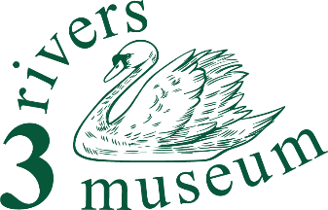

**Collections team member**

**Summary**

You’ll support the Curator and the Displays Manager in preparing, sorting and taking inventory of our collections.

The Collections Team also use our digital Collections Management System (Modes) to keep the records of what we hold and where it’s kept.

**Detailed description**

What will I do?

As requested by the Curator and Displays Manager, identify and locate items for display.

Help them keep the museum store in order.

(For some) use Modes to enter details of objects in our collection as we work to recover the ‘backlog’ of objects held in the museum but not recorded on the new system.

What will I need?

An orderly mind is the main requirement! An eye for good layout and design will be helpful.

Familiarity with computer-based records apps, such as Excel or Access, will be important for those getting involved with Modes.

The ability to lift moderately heavy objects will be an advantage.

What will I gain?

You ‘ll get experience of managing the collections of a small museum, using a modern digital management system. Many items will need fresh descriptions, so you’ll learn from that as well.

During 2024 and 2025 a considerable amount of conservation work will also be in hand.

And you will be helping our visitors to discover and learn from our collections making an input to our marketing effort, by providing attractive displays for the visitor to enjoy.

You'll be making a real contribution to an important component of the life of our Three Rivers communities, both helping the museum and helping people discover their area.

And you’ll get

… an enormous sense of well-being

… the opportunity to learn about the area, its people and their story

… the skills to help our visitors discover what it was like to live and work round here

… volunteer events, and

… a chance to transform our small museum into something even better than it is now.