**Three Rivers Museum**

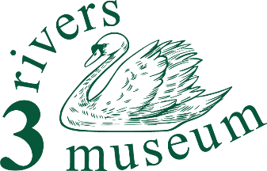

**Digital display and website team member**

**Summary**

You’ll look after and update the contents of our interactive digital display, and keep the website up to date.

**Detailed description**

What will I do?

We have an increasing collection of digital material, displayed in the museum on our interactive display kiosk and also on our website.

This role keeps the image and other files on the kiosk up to date, with frequent refreshment, and also makes sure that each file on display has a suitable description. Selection of suitable images will be important – not all are good enough, and may need to be re-worked.

At least one member of the team assists the chairman and marketing lead in keeping the website up to date. It‘s the main channel by which we provide information to the public, so it’s really important to what we do.

What will I need?

An orderly mind is the main requirement!

Ability to use a computer, with access to the internet, is essential. Experience with digital images will be very helpful.

You’ll need a bit of time, but it will be very flexible. Perhaps five hours a week (working mainly from home) would be reasonable, but could be increased as desired. Regular liaison with the chairman and digital and marketing leads will be essential.

What will I gain?

This offers an opportunity to gain experience in running the digital side of a small museum, and in looking after a medium sized website.

You'll be making a real contribution to an important component of the life of our Three Rivers communities, both helping the museum and helping people discover their area.

And you’ll get

… an enormous sense of well-being

… the opportunity to learn about the area, its people and their story

… the skills to help our visitors discover what it was like to live and work round here

… volunteer events, and

… a chance to transform our small museum into something even better than it is now.