**Three Rivers Museum**

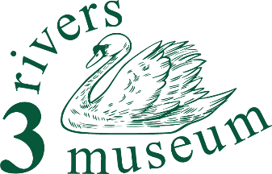

**Front of House and Steward**

**Summary**

After suitable training, you’ll present the museum as the visitor’s first point of contact, and be ready to take the first action when someone asks a question – or if an emergency occurs.

**Detailed description**

What will I do?

Working usually as a team of two, you’ll greet and welcome our visitors as they arrive. You’ll be able to respond to any question they may have, and direct them to the appropriate part of the museum’s displays and books – or take a note of their query, and pass it on to one of the museum’s historians.

You’ll have opened, set up and closed the museum.

And you’ll be ready to raise the alarm and take the immediate actions should any emergency arise.

What will I need?

You’ll want to be able to relate to people, to be ready to engage them and answer their questions.

Basic computer skills will allow you to better show our visitors how the IT equipment works, but aren’t essential.

2 hours per shift, weekly or monthly (less often than once a month really isn’t worth it – there’s too much happening).

What you can gain:

You could say, “Not much…” Except:

You'll be making a real contribution to an important component of the life of our Three Rivers communities, both helping the museum and helping people discover their area.

And you’ll get

… an enormous sense of well-being

… the opportunity to learn about the area, its people and their story

… the skills to help our visitors discover what it was like to live and work round here

… volunteer events, and

… a chance to transform our small museum into something even better than it is now.