**Three Rivers Museum**

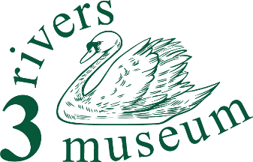

**Marketing team member**

**Summary**

Our marketing team presents our museum to the public of Three Rivers and beyond.

**Detailed description**

Our work isn’t done only in the museum. We know that we have to get out to the communities, individuals, schools and other groups in the district, and deliver to them the story that we exist to tell. That need them to be aware of what we do, and where we are.

We have a range of material ready to go in our Marketing Toolkit, and developing it further would be no bad thing.

What will I do?

You’ll use the templates and materials we already have to make up leaflets, flyers and advertisements. And you’ll keep up the ‘marketing calendar’, to make sure that we’ve planned our campaigns properly so that we make people aware of the events we’re planning.

Keeping the website up to date would be very helpful in this role as well.

What will I need?

Some experience in marketing and PR will be very helpful. The role offers considerable independence, within the agreed marketing toolkit, but you’ll need to know what’s going on in some detail.

Ability to use a computer is essential.

You’ll need a bit of time, but it will be very flexible. Perhaps five hours a week (working mainly from home, but closely with the trustees) would be reasonable.

What will I gain?

This offers an opportunity to gain experience in the marketing of a small charity and local museum.

You'll be making a real contribution to an important component of the life of our Three Rivers communities, both helping the museum and helping people discover their area.

And you’ll get

… an enormous sense of well-being

… the opportunity to learn about the area, its people and their story

… the skills to help our visitors discover what it was like to live and work round here

… volunteer events, and

… a chance to transform our small museum into something even better than it is now.