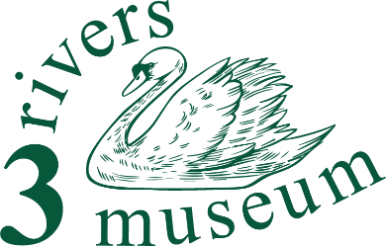

Three Rivers Museum
Volunteer role – our Marketing team
General description
Our local history museum in the middle of Rickmansworth exists to
“tell the story of what it was like to live and work round here”.

Our marketing team presents our museum to the public of Three Rivers and beyond.
More detail
Our work isn’t done only in the museum. We know that we have to get out to the communities, individuals, schools and other groups in the district, and deliver to them the story that we exist to tell. And we want to make them aware of what we do, and where we are.
We have a range of material ready to go in our Marketing Toolkit, although developing it further would be no bad thing.
You’ll use the templates and materials we already have to make up leaflets, flyers and advertisements. And you’ll keep up the ‘marketing calendar’, to make sure that we’ve planned our campaigns properly so that we make people aware of the events we’re putting on.
Keeping the website up to date would be very helpful in this role as well.

If you’re looking for some experience at the start of a career in marketing, this would be a good place to start!

