**Three Rivers Museum**

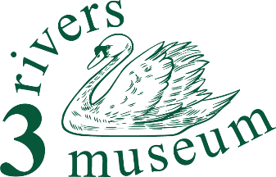

**Volunteer Champion and Team Leader**

**Summary**

You'll grow and look after the small group of volunteers in our local museum, by identifying what’s needed, finding people to do it and then supporting them.

**Detailed description**

Your purpose and impact:

Our museum is developing quickly, and our need for volunteers is increasing. Finding, coordinating and supporting them (with the trustees) will really help us as we work to provide our service to the Three Rivers public in new ways.

 The role:

You'll be involved in the museum’s activities so that you know what we do and how, and what jobs need to be done. You'll be recruiting volunteers, interviewing them (with colleagues) and allocating them to roles, arranging any training, and making sure they get the right guidance - not necessarily from you.

What you can gain:

You could say, “Not much…” Except:

You'll get an insight into museum management, and make a wide range of contacts. If you're looking to develop a career in the culture sector, it would be a cracking move!

And you'll be making a real contribution to an important component of the life of our Three Rivers communities, both helping the museum and providing opportunities to local people who also want to help.

So we think you’ll get

… an enormous sense of well-being

… the opportunity to learn about the area, its people and their story

… the skills to help our visitors discover what it was like to live and work round here

… volunteer events, and

… a chance to transform our small museum into something even better than it is now.